White Box Testing

# Code Snippet

# Control Flow Graph

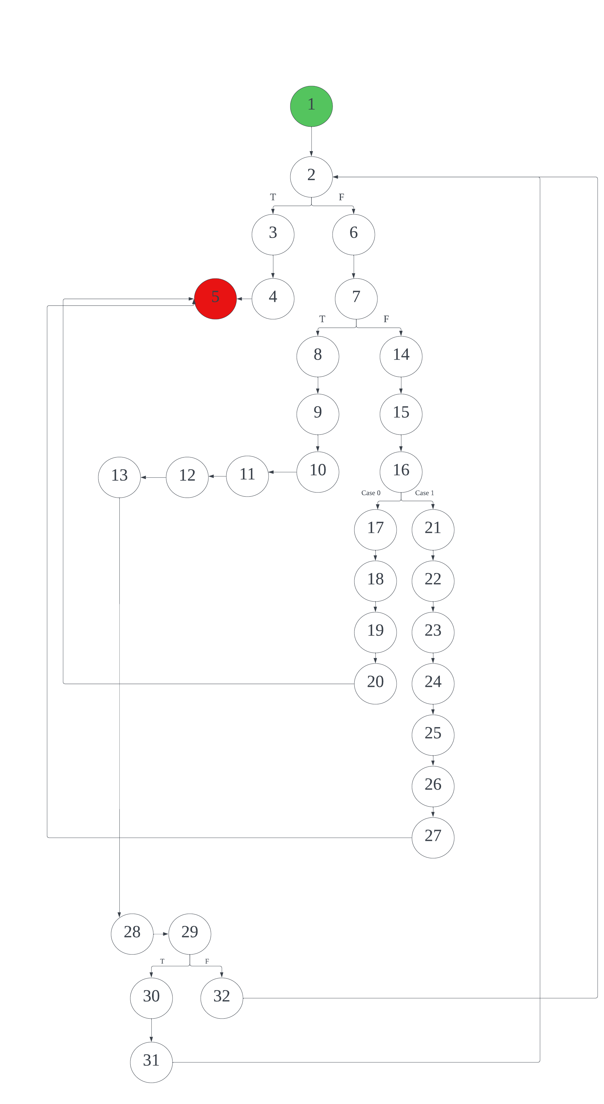

**Cyclomatic Complexity:** According to the Control Flow Graph above, there are 35 edges and 32 nodes. Thus, the cyclomatic complexity can be calculated using the formula: 35 – 32 + 2(1) = **5**.

**Basis Paths:**

# Path 1: 1 2 6 7 14 15 16 17 18 19 20 5

# Path 2: 1 2 6 7 14 15 16 21 22 23 24 25 26 27 5

# Path 3: 1 2 3 4 5

# Path 4: 1 2 6 7 8 9 10 11 12 13 28 29 30 31 2

# Path 5: 1 2 6 7 8 9 10 11 12 13 28 29 32 2

# Test Cases

From the code and the 5 basis paths that were identified, 5 test cases were created to test the functionality of the code.

